**Title:** Software for learning Pixel Group Processing

Course-Specific Learning Outcomes: after the completion of this project the following will have been learnt:

1. How e-learning can be used to educate people.
2. Follow proper programming conventions such as; DOM level 2+ core specification
3. Be able to develop clean, maintainable and readable code with explanatory comments
4. Understand the technique behind how filters are applied to images by pixel group processing
5. Be able to gain new skills and research skills needed to complete a project
6. Evaluate different learning technologies and how they can be applied in your own projects
7. Use information learned from previous unit such as web and multimedia to design the web interface

Project Background

In the modern day we can’t go a day without seeing images being displayed all around us and everyone has access to social photograph application such as Instagram, Tumblr, Flickr and thousands of others on the market. We are awash with images and most of them have filters applied to them how ever subtle the effect may be. The science behind this is pixel group processing. In pixel group processing we use a technique which uses a convolution matrix (Ludwig, J. (2007), where we take an image and apply mathematical convolution on every pixel with its neighbouring pixels weighted by a kernel matrix which could be 3x3 or whatever the developer desires. Wouldn’t pictures be just plain and boring without filters? That’s why this technique is important.

There are several reason why we may want to use a filter on an image e.g. to improve one’s appearance, photographers can use them to retouch old photos and bring them to life and many others.

In our case for computer science and more specifically computer vision (Urtasun, R. (2013)) it’s very useful to be able to have a preliminary step where we can use a convolution to get rid of noise in an image for example we could apply an edge detection convolution on our image to make it easier to recognize objects and get rid of unnecessary information (noise). Here’s an illustration that I made on Photoshop (figure a1.0).

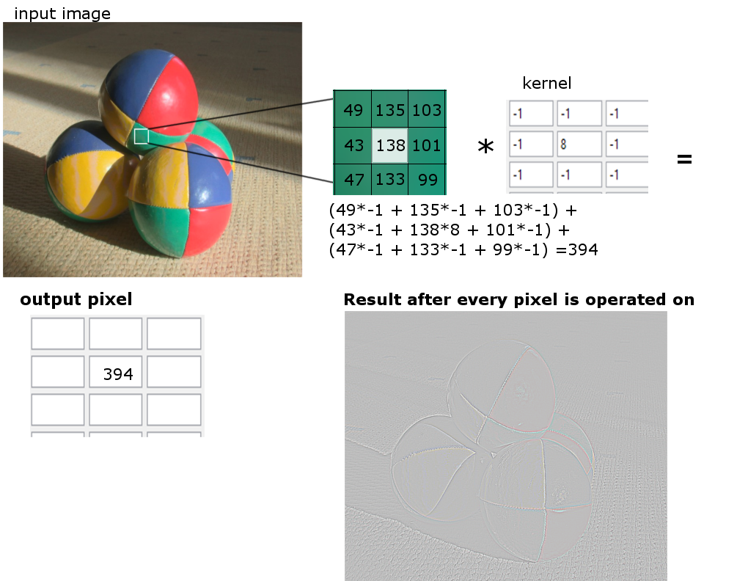

Figure a1.0

Most people have no idea about pixel group processing there I decided to do a project on it and teach it so that even a novice user or a student would be able to understand it and hopefully apply it in a project of their own.

Aim

The aim of this project is to use existing web technologies such as JavaScript and HTML5 to re author the original application (which was written in lingo) and make a user friendly interface that can teach the discipline of pixel group processing.

Objectives

The project objectives are as below;

* Use relevant tools (Google scholars, MMU library) to read articles and journals regarding pixel group processing
* Do some research on how people learn and best practices on e-learning
* Use Photoshop to design the web interface
* add features such as using being able to upload image and trying different convolutions on them
* Re-author the code from lingo to JavaScript
* Rigorously test the software for an bugs and fix if needed
* Give out a prototype to people and gather feedback on how much they’ve learned
* Redesign the interface depending on the feedback
* Stages you will go through to solve problem. Approach you will take to address them.

Problems

There isn’t any major problems in particular except for edge handling. Since we have to multiply by nearest neighbours what if the current pixel is on the right edge? Then there won’t be any neighbouring pixels on the right of it. So we have to find a way to handle this. There are 3 main ways to handle this;

* Extend: that part of the kernel is skipped and not operated on
* Wrap: pixels from the opposite border will be used instead
* Crop: we just crop the pixels on the edges

Required Resources

No additional resources needed, a computer loaded with a JavaScript and HTML5 IDE and a browser is all that’s needed.

Schedule

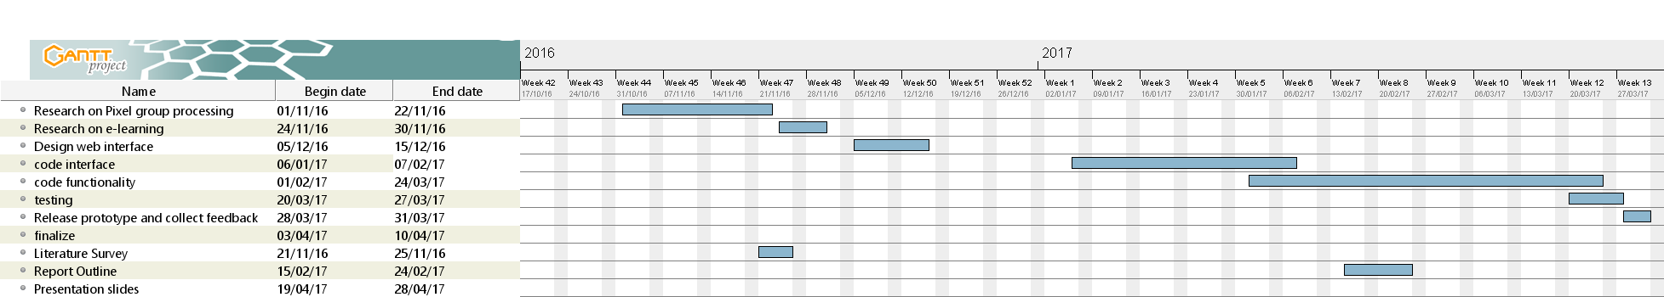

# Bibliography

Ludwig, J. (2007) *Image Convolution*. [Online] [Accessed on 20th October 2016] http://web.pdx.edu/~jduh/courses/Archive/geog481w07/Students/Ludwig_ImageConvolution.pdf

Urtasun, R. (2013) Computer vision: Filtering. [Online] [Accessed on 20th October 2016] http://www.cs.toronto.edu/~urtasun/courses/CV/lecture02.pdf